1. Hostname change - necessory? - Should it match with system hostname and DNS? - wothout DNS name can I use localhost or default hostname?

sudo hostnamectl set-hostname localhost

./mirror-registry install --quayHostname localhost:8443 --quayRoot /root/ocp/mirror-repo/quay/config/ --initPassword RedH@T123 --quayStorage /root/ocp/mirror-repo/quay/data/

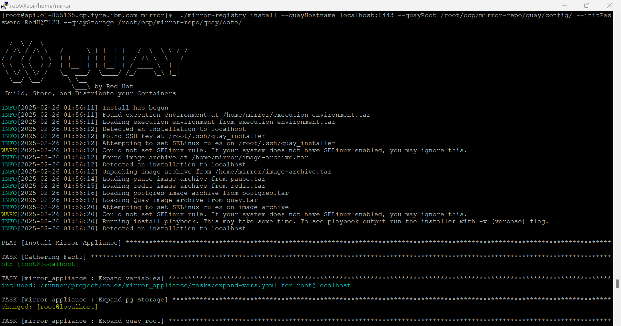

5. What is the default password? - How to change it?

Random password will be generated, --initPassword needs to be set to set a password explicitly

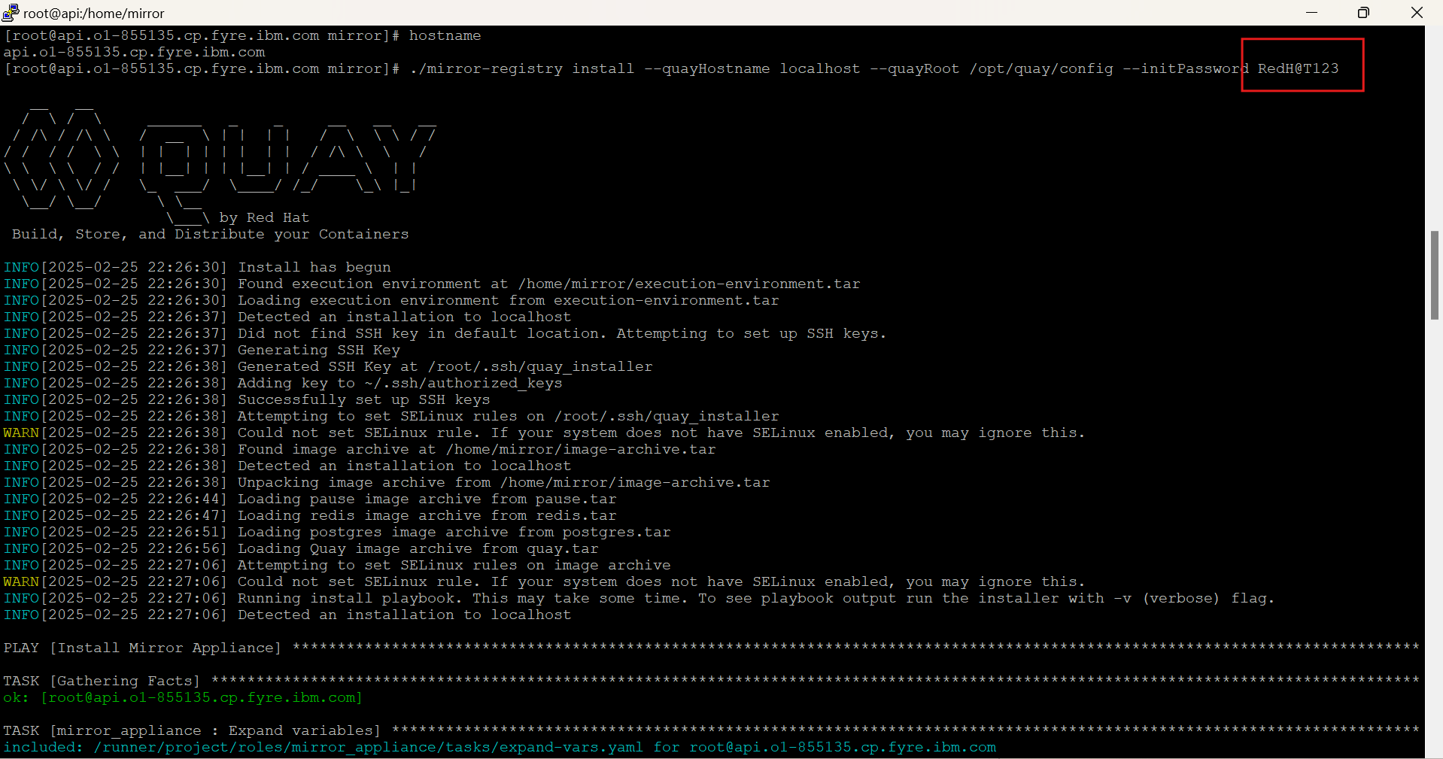



3. How to change port during the installation?

Pass the required port along with hostname --quayHostname

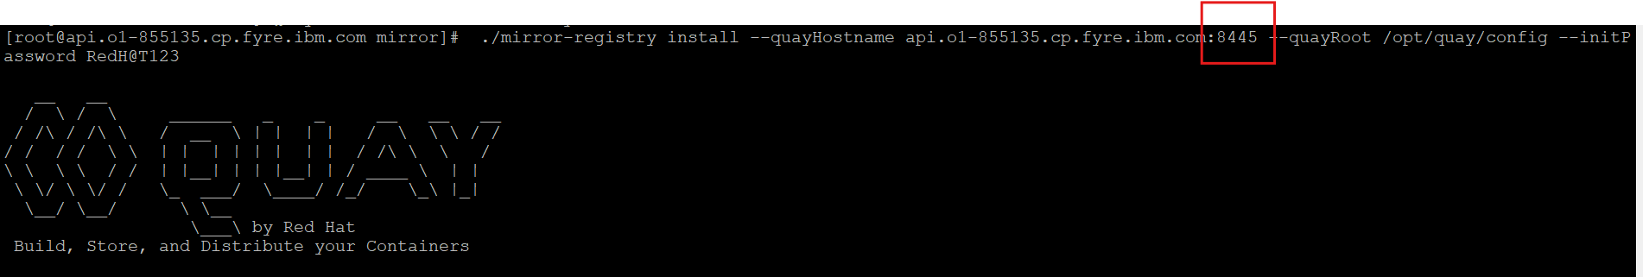



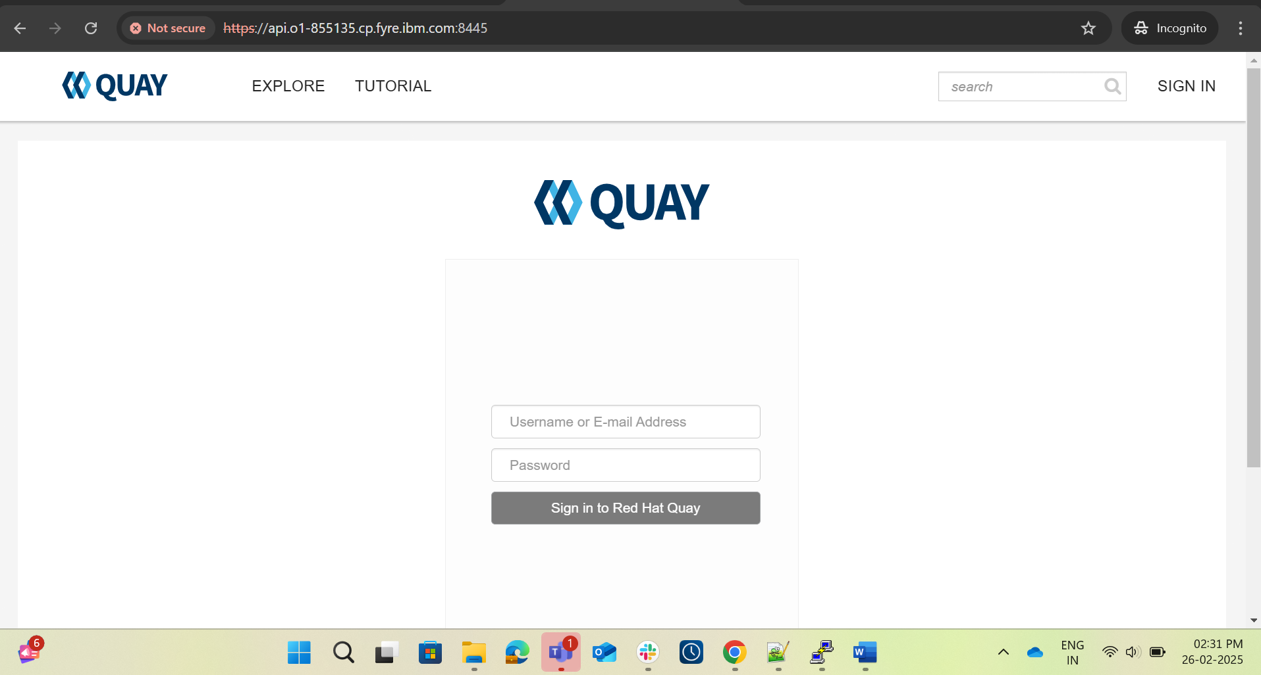

4. /mirror-registry install --quayHostname localhost --quayRoot /root/ocp/quay/config working

./mirror-registry install --quayHostname localhost --quayRoot /root/ocp/mirror-repo/quay/config --initPassword RedH@T123 --quayStorage /root/ocp/mirror-repo/quay/data/ -vv - not working

Working as per below

./mirror-registry install --quayHostname api.o1-855135.cp.fyre.ibm.com:8445 --quayRoot /root/ocp/mirror-repo/quay/config/ --initPassword RedH@T123 --quayStorage /root/ocp/mirror-repo/quay/data/

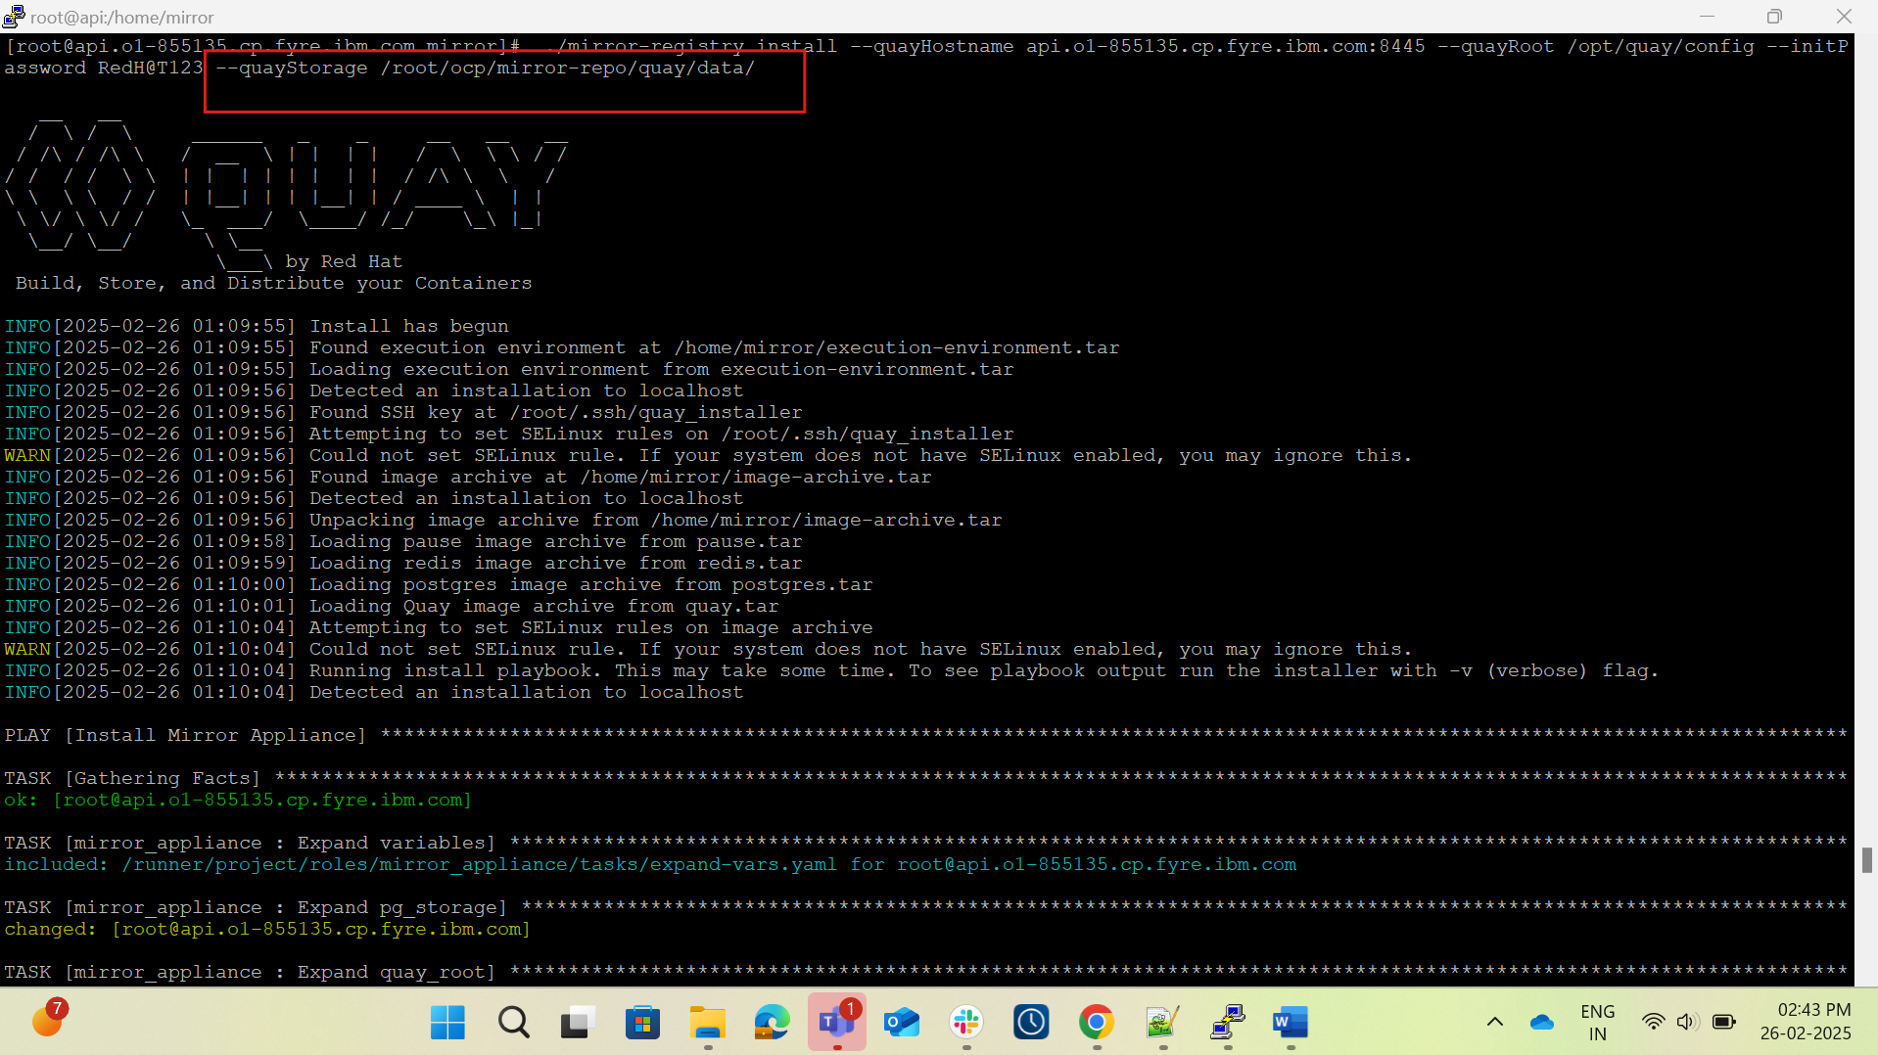

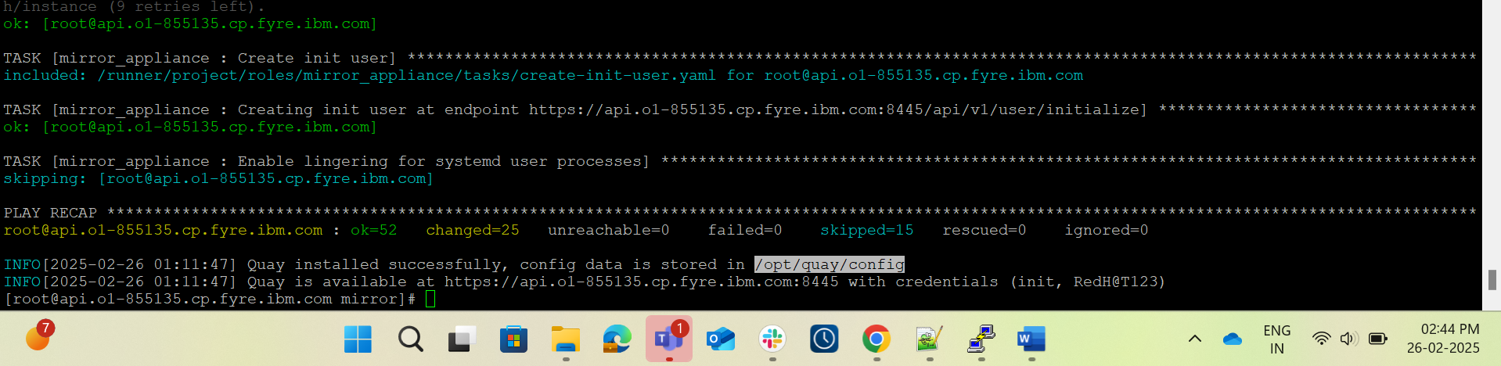

6. how to change SSL certs? Where is it located?

